Date:

# EXPERIMENT NO. 2

#### AIM: Implement a circuit in Logisim which perform Addition and Subtraction of sign

#### number.

**ALGORITHM:**

**CIRCUITS:**

**+81 + +55**

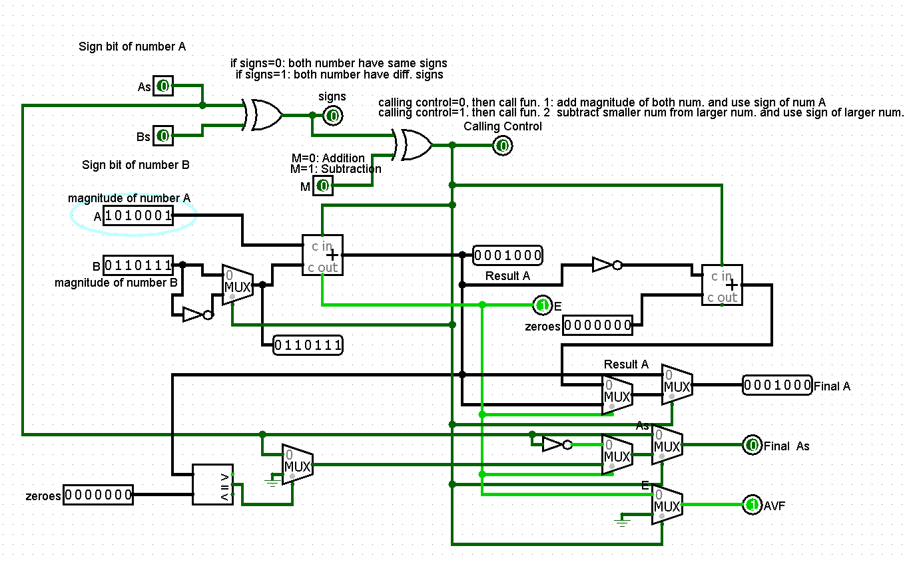

**+81 - +55**

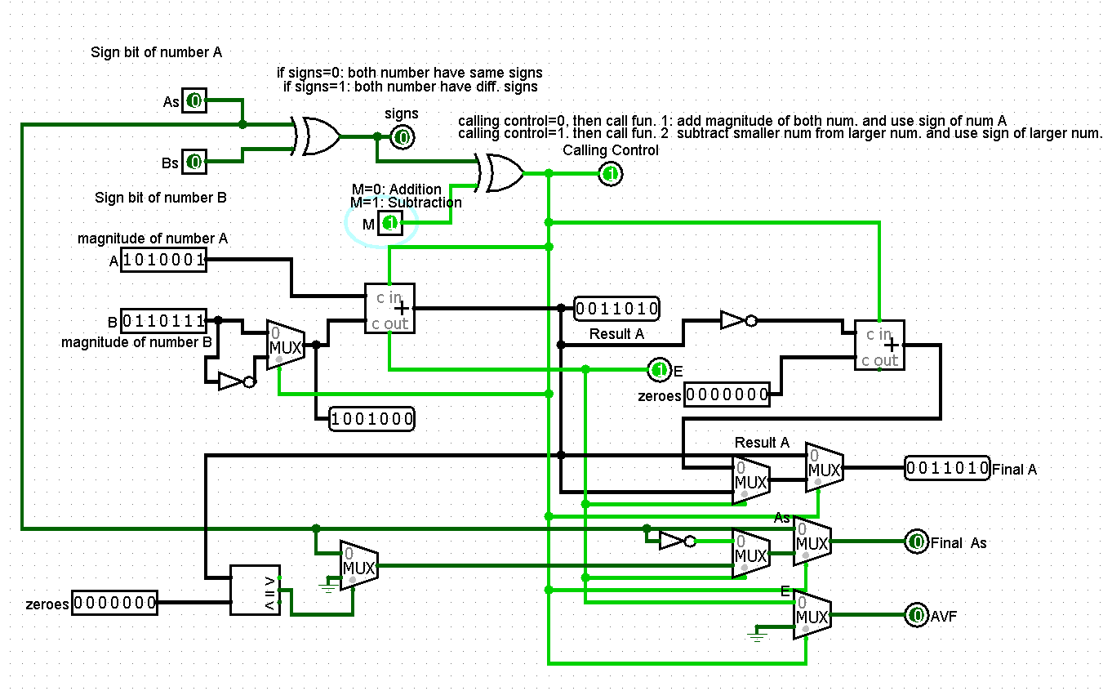

**-81 + -55**

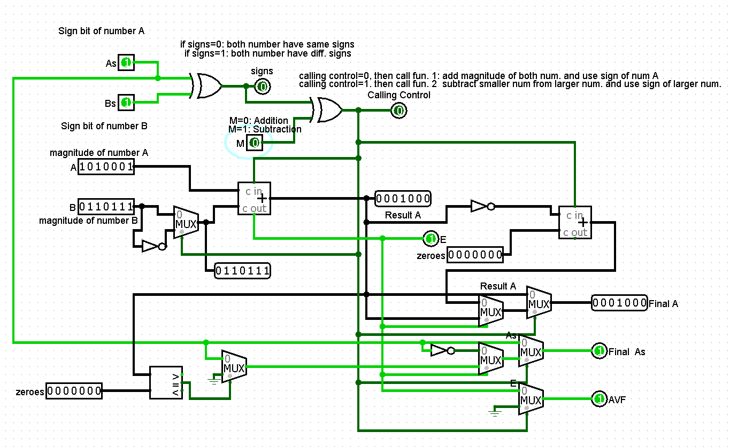

**-81 - -55**

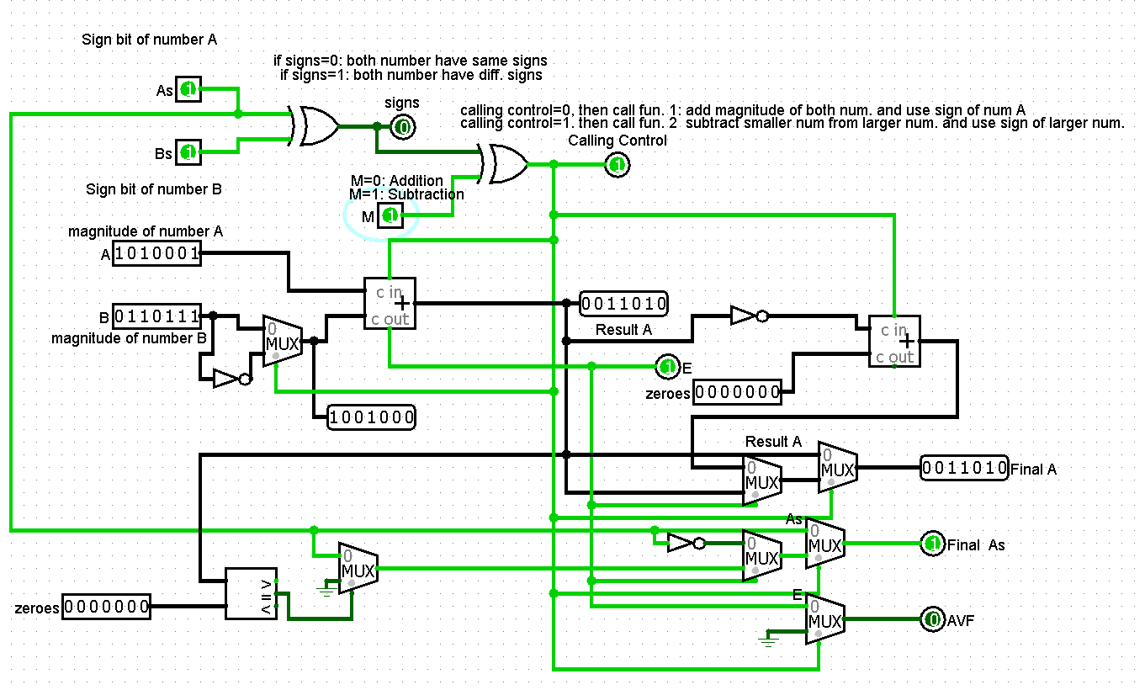

**-81 + +55**

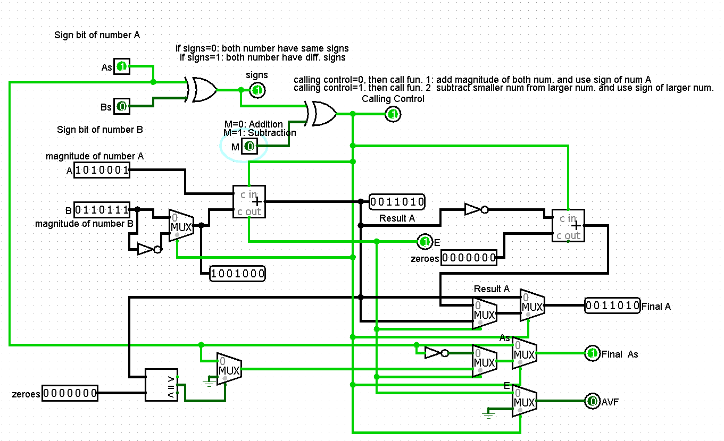

**-81 - +55**

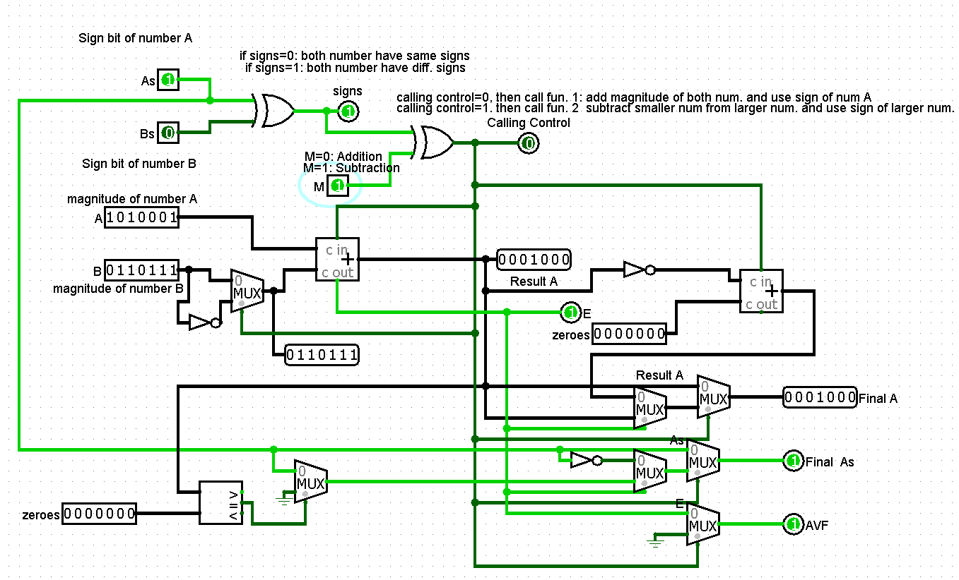

**CONCLUSION:**